AI-Enabled IoT Smart Anganwadi System for Real-Time ICDS Monitoring and Malnutrition Risk Prediction

1.Project Introduction:
The AI-Enabled IoT Smart Anganwadi System for Real-Time ICDS Monitoring and Malnutrition Risk Prediction is designed to improve child health monitoring in Anganwadi centers under the Integrated Child Development Services (ICDS) scheme. The system automates the measurement of a child’s height and weight using an ultrasonic sensor and load cell with HX711 amplifier, while RFID technology is used for attendance and child identification.
The collected data is processed using an ESP32 microcontroller to calculate BMI (Body Mass Index) and Z-score, which helps in identifying the nutritional condition and risk level of children. The processed data is monitored in real-time using Blynk and ThingSpeak platforms, enabling efficient tracking of child growth, attendance, and nutritional status. This low-cost IoT solution helps reduce manual effort and supports better decision-making for child healthcare monitoring.
2. Circuit Diagram:
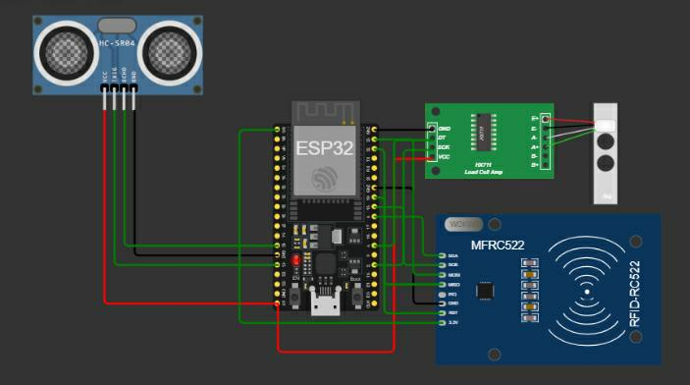

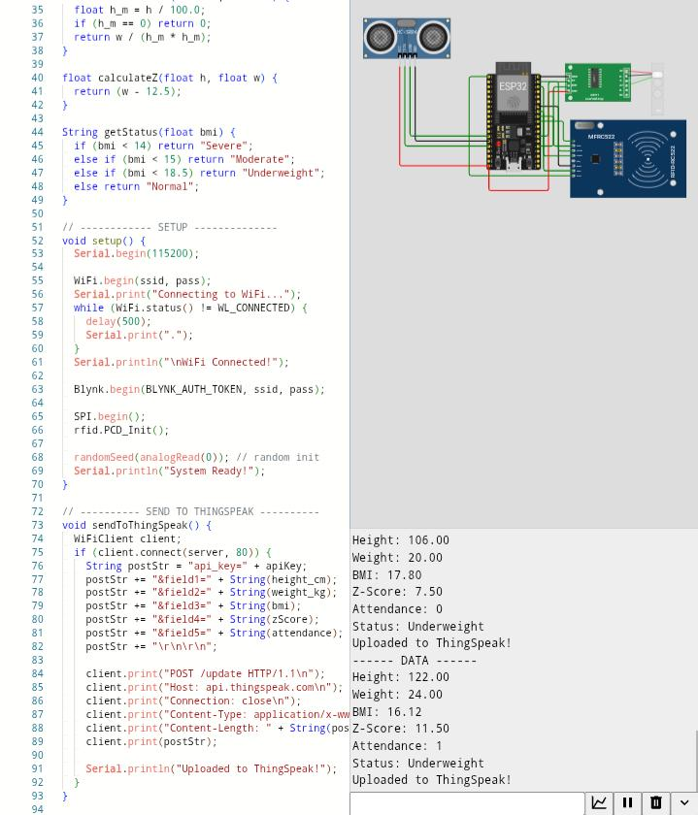
3.Wokwi Simulation Output:

4.Blynk Output :
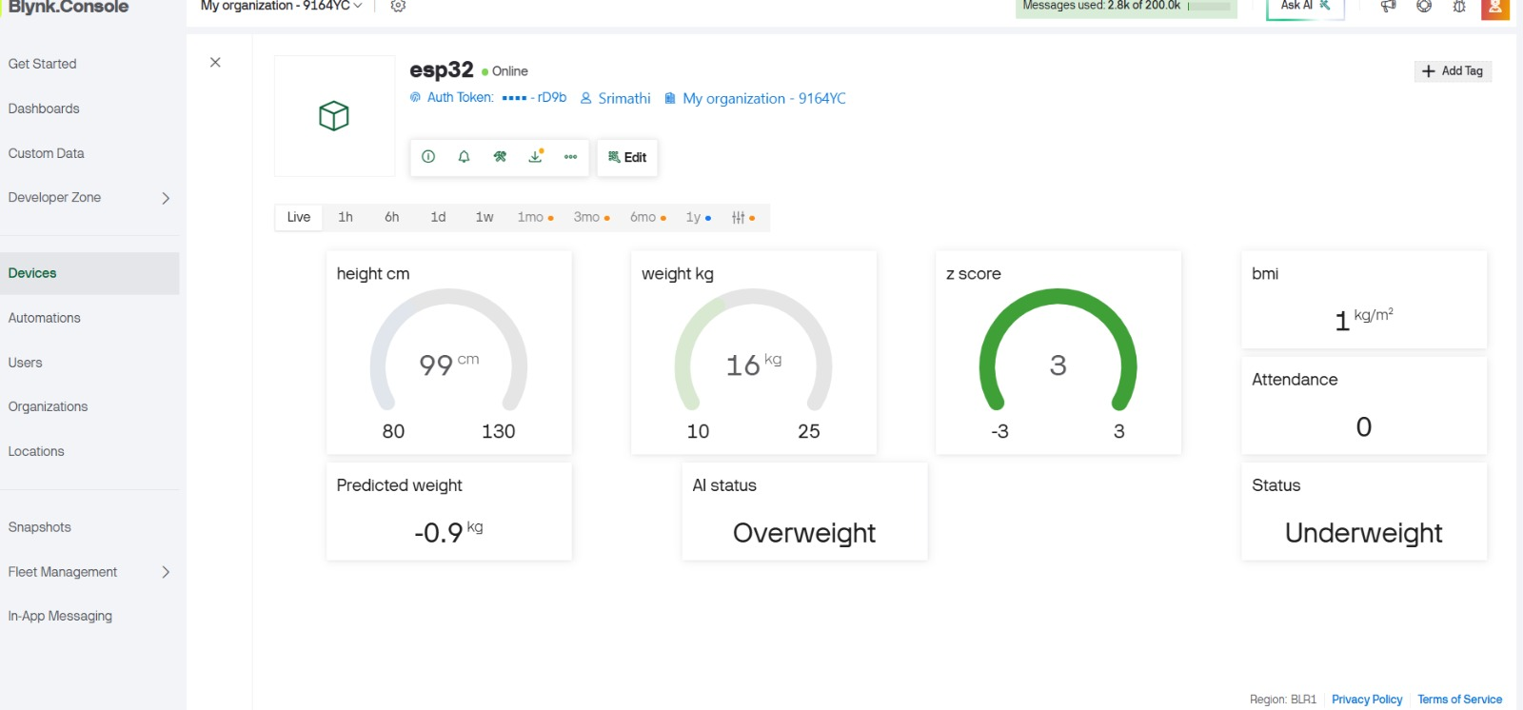

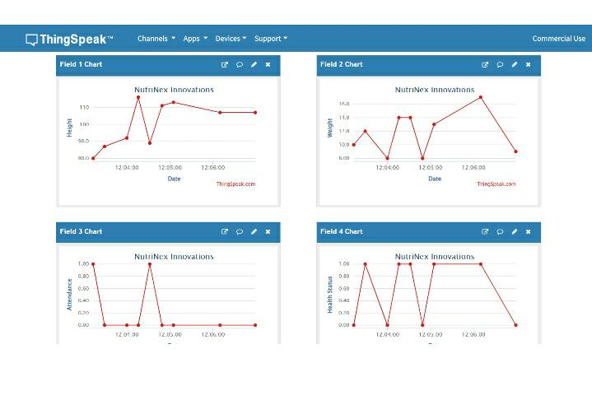
5.ThingSpeak Graph :
6.Output Parameters:
Height
Weight
BMI
Z-Score
Attendance
Risk Level

7.Working Procedure:
Ultrasonic sensor → height measure
Load cell + HX711 → weight measure
RFID → attendance/identification
ESP32 → data processing
BMI & Z-score calculation → risk prediction
Blynk + ThingSpeak → real-time monitoring

